  Requirements document for an information system development project | Members  Tiago Martins 52052532 Zoe Claassens 50959042 Knowledge Tshabalala 55456367 Ruby Nyabvure 49948989 Lihle Tshona 51748584 Thokozani Mahlangu 50833464 Arnold Photsane 39156222

Project Plan
# | ID | Task / Deliverable | Assigned To | Start Date | Duration | End Date | % Complete | Status | Phase
 | 1.0 | PHASE 1 — SCOPE DEFINITION |  |  | 27 Jan 2026 | 29 Jan 2026
1 | 1.1 | Define project boundaries and operational areas | All Team | 27 Jan 2026 | 1 days | 27 Jan 2026 | 100% | Complete | Phase 1
2 | 1.2 | Draft project proposal document | All Team | 28 Jan 2026 | 1 days | 28 Jan 2026 | 100% | Complete | Phase 1
3 | 1.3 | Obtain sponsor sign-off from James Baxter | Project Manager | 29 Jan 2026 | 1 days | 29 Jan 2026 | 100% | Complete | Phase 1
 | 2.0 | PHASE 2 — PROBLEM ANALYSIS |  |  | 30 Jan 2026 | 19 Feb 2026
4 | 2.1 | Interview department managers | System Analyst | 30 Jan 2026 | 5 days | 05 Feb 2026 | 100% | Complete | Phase 2
5 | 2.2 | Document existing process inefficiencies and gaps | System Analyst | 06 Feb 2026 | 5 days | 12 Feb 2026 | 100% | Complete | Phase 2
6 | 2.3 | Identify business opportunities and economic justification | All Team | 13 Feb 2026 | 4 days | 18 Feb 2026 | 100% | Complete | Phase 2
7 | 2.4 | Submit project proposal | Project Manager | 19 Feb 2026 | 1 days | 19 Feb 2026 | 100% | Complete | Phase 2
 | 3.0 | PHASE 3 — REQUIREMENTS ANALYSIS |  |  | 20 Feb 2026 | 03 Apr 2026
8 | 3.1 | Plan and schedule stakeholder workshops | Project Manager | 20 Feb 2026 | 3 days | 24 Feb 2026 | 100% | Complete | Phase 3
9 | 3.2 | Conduct requirements workshops — Employees module | System Analyst | 25 Feb 2026 | 5 days | 03 Mar 2026 | 100% | Complete | Phase 3
10 | 3.3 | Conduct requirements workshops — Ticketing module | System Analyst | 04 Mar 2026 | 5 days | 10 Mar 2026 | 100% | Complete | Phase 3
11 | 3.4 | Conduct requirements workshops — Animal Care module | System Analyst | 11 Mar 2026 | 5 days | 17 Mar 2026 | 100% | Complete | Phase 3
12 | 3.5 | Conduct requirements workshops — Restaurant module | System Analyst | 18 Mar 2026 | 5 days | 24 Mar 2026 | 100% | Complete | Phase 3
13 | 3.6 | Document functional requirements (BRS) | System Analyst | 25 Mar 2026 | 5 days | 31 Mar 2026 | 100% | Complete | Phase 3
14 | 3.7 | Document non-functional requirements (security, performance) | System Analyst | 01 Apr 2026 | 3 days | 03 Apr 2026 | 100% | Complete | Phase 3
15 | 3.8 | Submit project proposal | Project Manager | 27 Mar 2026 | 1 days | 27 Mar 2026 | 100% | Complete | Phase 3
 | 4.0 | PHASE 4 — LOGICAL DESIGN |  |  | 30 Mar 2026 | 08 May 2026
16 | 4.1 | Develop context diagrams and DFDs (level 0 & 1) | System Analyst | 30 Mar 2026 | 8 days | 08 Apr 2026 | 0% | Not Started | Phase 4
17 | 4.2 | Design Entity-Relationship Diagrams (ERDs) — all modules | System Analyst | 09 Apr 2026 | 8 days | 20 Apr 2026 | 0% | Not Started | Phase 4
18 | 4.3 | Define data dictionary | System Analyst | 21 Apr 2026 | 5 days | 27 Apr 2026 | 0% | Not Started | Phase 4
19 | 4.4 | Define system modules and specifications | All Team | 28 Apr 2026 | 5 days | 04 May 2026 | 0% | Not Started | Phase 4
20 | 4.5 | Produce Logical System Design document | System Analyst | 05 May 2026 | 3 days | 07 May 2026 | 0% | Not Started | Phase 4
21 | 4.6 | Logical design review with stakeholders | Project Manager | 08 May 2026 | 1 days | 08 May 2026 | 0% | Not Started | Phase 4
 | 5.0 | PHASE 5 — PHYSICAL DESIGN & INTEGRATION |  |  | 11 May 2026 | 13 Jul 2026
22 | 5.1 | Design physical database schema | System Analyst | 11 May 2026 | 8 days | 20 May 2026 | 0% | Not Started | Phase 5
23 | 5.2 | Develop UI wireframes — Employee & Ticketing modules | All Team | 21 May 2026 | 8 days | 01 Jun 2026 | 0% | Not Started | Phase 5
24 | 5.3 | Develop UI wireframes — Animal Care & Restaurant modules | All Team | 02 Jun 2026 | 8 days | 11 Jun 2026 | 0% | Not Started | Phase 5
25 | 5.4 | Build prototypes for each module | All Team | 12 Jun 2026 | 10 days | 25 Jun 2026 | 0% | Not Started | Phase 5
26 | 5.5 | Prototype usability testing with users | System Analyst | 26 Jun 2026 | 5 days | 02 Jul 2026 | 0% | Not Started | Phase 5
27 | 5.6 | Document redesigned business processes | System Analyst | 03 Jul 2026 | 5 days | 09 Jul 2026 | 0% | Not Started | Phase 5
28 | 5.7 | Produce Physical Design & detail specifications document | System Analyst | 10 Jul 2026 | 2 days | 13 Jul 2026 | 0% | Not Started | Phase 5
 | 6.0 | PHASE 6 — INSTALLATION |  |  | 14 Jul 2026 | 06 Oct 2026
29 | 6.1 | Configure hardware and network infrastructure | IT Staff | 14 Jul 2026 | 10 days | 27 Jul 2026 | 0% | Not Started | Phase 6
30 | 6.2 | Deploy system to production environment | IT Staff | 28 Jul 2026 | 10 days | 10 Aug 2026 | 0% | Not Started | Phase 6
31 | 6.3 | Conduct User Acceptance Testing (UAT) — all modules | System Analyst | 11 Aug 2026 | 10 days | 24 Aug 2026 | 0% | Not Started | Phase 6
32 | 6.4 | Resolve UAT issues and defects | All Team | 25 Aug 2026 | 10 days | 07 Sept 2026 | 0% | Not Started | Phase 6
33 | 6.5 | Deliver staff training sessions | Project Manager | 08 Sept 2026 | 10 days | 21 Sept 2026 | 0% | Not Started | Phase 6
34 | 6.6 | Produce operation manual | System Analyst | 22 Sept 2026 | 7 days | 30 Sept 2026 | 0% | Not Started | Phase 6
35 | 6.7 | Conduct quality review and produce report | All Team | 01 Oct 2026 | 3 days | 05 Oct 2026 | 0% | Not Started | Phase 6
36 | 6.8 | Final sponsor sign-off and project closure | Project Manager | 06 Oct 2026 | 1 days | 06 Oct 2026 | 0% | Not Started | Phase 6

DEFINITIONS, ACRONYMS and ABBREVIATIONS
- GUI: Graphical user interface
- IDE: Integrated Development Environment
- DBMS: Data base management system
- PERT Chart: Program Evaluation Review Technique Chart
- COTS: Commercial off the shelf
- EST: Earliest Start Time
- LCT: Latest Completion Time
- RAD: Rapid Application Development
Definitions
- Gantt Chart: a visual timeline for scheduling tasks with blocks representing the time it takes to complete an activity
- Critical path: A set of activities that have no slack time and if not managed properly will delay the project as a whole
- PERT Chart: a project management tool used to schedule and coordinate tasks in a project

PROJECT DESCRIPTION AND SCOPE
The goal of this project is to develop a technological system to AquaCore Aquarium to support its daily business operations. The system should automate key functions like ticket sales and manage employees, marine life and the restaurant. The system should also assist in having a back up feature to prevent the loss of important data as well as have security measures to make sure to prevent unauthorized users from gaining access to sensitive information. Before we can implement the new system, all existing data will have to be backed up to the cloud. The RAD methodology and several phases will be used to develop prototypes which can be tested by users to get continuous feedback as well as improvements. The following functionality will be included in the scope of this project:

The system must satisfy the following requirements:
- Maintenance of Marine life
- Maintenance of Customers
- Maintenance of Employees
- Maintenance of Restaurant
- Buying tickets
- Buying food, including time and what bought
- Marine life check-up
- Simple GUI
- Data backup
- Secure storage of information
- Reporting of transactions within the aquarium, Monthly revenue generated, Ticket sales for a period, Restaurant sales for a period

4. FUNCTIONAL REQUIREMENTS
AquaCore System GUI Structure

MAIN MENU
Employee Management
Ticket & Client Management
Animal Management
Restaurant Management
Reports / Revenue
Logout
↓ ↓ ↓ ↓
EMPLOYEE MENU  Add Employee  Update Employee  Delete Employee  Back | TICKET MENU  Sell Ticket  Manage Client  Back | ANIMAL MENU  Add Animal  Update Animal  Back | RESTAURANT MENU  Process Order  Inventory  Revenue  Back

🔹 4.1 Employee Management
➤ Add New Employee
Input: | Processing: | Output:
- Employee ID (auto generated) | - Validate all required fields are completed | - Confirmation message with Employee ID
- Name & Surname | - Ensure no duplicate employee exists | - Employee record stored in database
- Department (Animal Care / Ticket Sales / Restaurant / Maintenance) | - Assign role-based access rights
- Role
- Contact details
- Work schedule
➤ Update Employee Details
Input: | Processing: | Output:
- Employee ID (selected from list) | - Retrieve existing employee data | - Confirmation message
- Updated employee details | - Validate updated inputs
 | - Save updated data
➤ Delete Employee
Input: | Processing: | Output:
- Employee ID | - Confirm deletion request | - Confirmation message
 | - Remove employee record
🔹 4.2 Ticket & Client Management
➤ Sell Ticket
Input: | Processing: | Output:
- Ticket type | - Calculate total cost | - Digital/printed ticket
- Number of tickets | - Generate unique ticket ID | - Receipt
- Client details (optional but recommended) | - Record transaction | - Updated revenue records
➤ Manage Client Records
Input: | Processing: | Output:
- Client ID | - Add/update/delete client info | - Confirmation message
- Name | - Link client to ticket purchases | - Updated client database
- Contact details
🔹 4.3 Animal Management
➤ Add Animal Record
Input: | Processing: | Output:
- Animal ID | - Validate inputs | - Confirmation message
- Type Animal | - Store animal data
- Feeding schedule
- Medical records
➤ Update Animal Records
Input: | Processing: | Output:
- Animal ID | - Validate updates | - Updated animal profile
- Updated health/feeding info | - Save changes
🔹 4.4 Restaurant Management
➤ Process Orders
Input: | Processing: | Output:
- Menu items selected | - Calculate total bill | - Receipt
- Quantity | - Record sale | - Updated sales data
➤ Inventory Management
Input: | Processing: | Output:
- Stock levels | - Update inventory | - Low stock alerts
- New stock entries | - Detect low stock | - Updated inventory list
➤ Track Revenue
Input: | Processing: | Output:
- Ticket sales data | - Aggregate total revenue | - Daily/monthly revenue summary
🔹 4.6 Security & Access Control
➤ User Login
Input: | Processing: | Output:
- Username | - Authenticate user | - Access granted/denied
- Password | - Determine access level

Non-Functional requirements
1. Non-Functional Requirements
Performance & Efficiency
- Response Time: The system must process ticket sales and restaurant orders in under 2 seconds to prevent visitor bottlenecks at the entrance or dining area.
- Throughout: The database must handle at least 50 concurrent users (staff/admin) during peak holiday hours without performance degradation.
Security & Control
- Role-Based Access Control (RBAC): The system must restrict access based on department (e.g., Ticket Sales staff cannot access Animal Medical records) to prevent the security incidents mentioned in the background.
- Data Integrity: All financial transactions and animal health logs must be encrypted and backed up daily to the cloud and local NAS to prevent data loss.
Usability & Reliability
- User-Friendliness: The interface must be intuitive enough so that staff can be trained in under 4 hours, aligning with the goal of a "simple interface".
- Availability: The system should have an uptime of 99.9% during aquarium operating hours (8:00 AM – 6:00 PM).
Maintainability & Portability
- Scalability: The system architecture must allow for the addition of new departments (like a Gift Shop) in the future without full redesign.
- Compatibility: The software must run on existing Windows Server infrastructure and be accessible via the proposed staff tablets.

Candidate System Matrix
Characteristic | Manual System | COTS Package | Custom-Built System
System Overview | The existing solution is mostly manual, with little computerization. It is based on simple computerization and manual handling. The solution is not integrated or scalable for organizational growth. | The solution is a vendor-provided commercial off-the-shelf solution. It is based on a reliable solution that is supported by vendors. It is developed by someone else and is used after configuration. | The proposed solution is a completely customized system that has been made just for the organization. This is because it caters to the technical needs of the organization.
Technical Feasibility | The system utilizes existing infrastructures without any need for additional technical requirements. However, the system lacks any form of automation, integration, and modern system capabilities. This has led to the underutilization of technical resources and innovation. | The system provides a stable vendor-supported technology with set standards for performance. However, there is a possibility of challenges in integrating the system with existing systems, considering the compatibility factors. Technical dependence on the vendor is a critical factor. | The system is developed based on internal expertise, providing total control over the design and functionality of the system. It supports integration, scalability, and modern architectural standards, providing technical flexibility for continuous improvement and innovation.
Operational Feasibility | The operational processes remain the same, thus ensuring user familiarity. However, inefficiencies and delays still exist in the course of performing daily activities. The system does not allow for the optimization of processes or improvement of workflows. | Improves operational efficiency through automated modules and workflows. There is a slight mismatch with business processes, thus requiring organizational changes. Users need to become accustomed to the functionalities of the system. | Aligned to organizational workflows to ensure maximum efficiency of processes. Meets user needs and increases productivity through customized functionalities. Staff contribution to the development of the system ensures its usability.
Risk Assessment | The risks are high in system operation and data. This is attributed to the lack of control of the system. The risks are characterized by issues such as loss of data, inaccuracy, and non-compliance. The system's capability for risk mitigation is also low. This is because of the lack of system safeguards. | The system reduces risks through the compliance and update functions offered by the vendor. However, this also poses a risk of external dependencies. The system's risks are partially managed by the service provider. | This system encourages proactive risk management through the use of internal control mechanisms. The security, compliance, and integrity of the system are maintained based on the organization's standards. The risks are actively managed and mitigated by the development team.
Economic Feasibility | The system incurs minimal costs as existing resources are utilized, though inefficiency leads to increased costs in the long term. The inefficiency leads to financial loss in the long term. | The system incurs moderate costs, which are predictable in the form of subscription or license fees. The system offers faster return on investment in the form of increased efficiency. The long-term costs depend on the pricing model of the vendor. | The system incurs a high cost in terms of development and resources in the long term. The system offers cost savings in the long term in the form of increased efficiency and decreased dependency. The financial benefits are realized in the long term as the system grows.
Schedule Feasibility | This system is already in place and does not require any time for implementation. However, the system does not facilitate future development or enhancements. The progress of the organization can be impeded by the limitations of the system. | The system can be implemented within a short period of time. The implementation of the system depends on the vendor's time and configuration process. | The system requires a longer life cycle for development due to the process involved. The implementation process of the system can be done in phases. This will be very useful in avoiding delays in the project. The project timelines are controlled internally. This will be very useful in achieving better alignment.
Organizational Impact | This system also maintains the status quo in the existing culture of work and user familiarity. However, this system results in poor morale among the users due to inefficiency in the process. There is also little scope for improving the organization. | The system introduces new processes that may require cultural changes. Training is essential for user acceptance with minimal resistance to change. Organizational change is moderate; however, it is still manageable. | The system enables positive change in the organization with processes tailored to meet user requirements. User involvement leads to better acceptance with minimal resistance to change. It encourages a more efficient work environment with the use of technology.
Legal & Compliance | The system does not have proper mechanisms for ensuring regulatory compliance. Data protection and governance standards are not being properly addressed. This puts the organization in a potential legal risk. | The system is in compliance with industry standards through vendor-managed updates. It also meets legal requirements, but the vendor has control over this. | It is designed to meet all legal and regulatory requirements. Having total control over compliance also means that data protection standards are being addressed. It is also possible to implement updates as regulations are being changed.
Overall Evaluation | The system is not an efficient solution for long-term use due to its inefficiency and risk. It does not meet current business and technical needs. It has to be replaced for organizational development. | The system is an efficient and reliable solution with moderate limitations. It offers an effective trade-off between costs, efficiency, and speed of implementation | It is an alternative solution to custom development. The system is the most suitable solution based on flexibility and efficiency. It offers long-term strategic benefits despite its higher costs. It is recommended as the most suitable solution.

Suitable Candidate
The Custom-Built System is the preferred candidate because it offers a system that is completely aligned with the specific needs of the organization, both from an operational and a technical perspective. It also offers a system with a very high degree of flexibility, scalability, and integrability, so that it can grow with future business needs, as well as ensuring full internal control within the system. Although it requires a greater investment of time and money, it also provides greater value in the long term in terms of efficiency, user acceptance, and risk and compliance management.

Feasibility Systems Matrix (hypothetical)
Feasibility Dimension | Weight (%) | Candidate 1: Manual System | Candidate 2: COTS Package | Candidate 3: Custom-Built System
Technical | 20 | The solution will be able to continue using existing tools with no new training, but it cannot automate or integrate modern processes. Outcome: Team skills are wasted; company remains outdated.  Score: 10 | The solution will be able to provide reliable vendor-supported technology, but integration will be challenging since the system is foreign to the team. Outcome: Company gains stability, but team struggles to adapt.  Score: 70 | The solution will be able to deliver a tailored technical platform, and the team’s expertise ensures robust, scalable development. Outcome: Company gains modern, future-proof technology.  Score: 100
Operational | 10 | The solution will be able to maintain current workflows cheaply, but staff frustration and inefficiency will persist. Outcome: Operations stagnate; team cannot improve processes.  Score: 10 | The solution will be able to improve efficiency with vendor modules, but workflows may not fully match AquaCore’s unique needs. Outcome: Company improves moderately; team adapts to vendor limits.  Score: 60 | The solution will be able to align perfectly with AquaCore’s operations, and the team can involve staff in testing to maximize acceptance. Outcome: Smooth operations, higher staff satisfaction.  Score: 100
Risk | 20 | The solution will be able to operate without new risks, but data loss and compliance failures remain critical issues. Outcome: Company faces high risk, team powerless to mitigate.  Score: 0 | The solution will be able to reduce risks with vendor compliance, but reliance on the vendor is unavoidable. Outcome: Company gains stability, team monitors dependency.  Score: 70 | The solution will be able to control risks internally, and the team’s expertise ensures strong oversight and secure design. Outcome: Company gains resilience, team actively manages risks.  Score: 90
Economic | 20 | The solution will be able to minimize upfront costs, but inefficiencies will create hidden long-term expenses. Outcome: Company saves now, loses later; team effort wasted.  Score: 10 | The solution will be able to deliver faster Return on investment, but ongoing subscription/licensing costs remain outside team control. Outcome: Company gains short-term savings, team manages budgets.  Score: 70 | The solution will be able to justify high upfront investment, and the team’s skill ensures long-term savings through efficiency gains. Outcome: Company invests heavily but benefits long-term.  Score: 60
Schedule | 10 | The solution will be able to continue immediately, but the team cannot deliver improvements or new features over time. Outcome: Company stays stagnant, team idle.  Score: 10 | The solution will be able to deploy quickly, and the team can accelerate training and integration, but AquaCore must adapt to vendor timelines. Outcome: Company improves fast, team limited by vendor pace.  Score: 80 | The solution will be able to deliver phased, future-proof development, and the team’s project management skills reduce delays. Outcome: Company waits longer but gains sustainable system.  Score: 80
Cultural | 10 | The solution will be able to keep staff routines familiar, but frustration and inefficiency will persist. Outcome: Company morale stays low, team impact limited.  Score: 0 | The solution will be able to introduce modern workflows, and the team can manage resistance through training, but staff may resist generic processes. Outcome: Company modernizes; team handles change.  Score: 70 | The solution will be able to increase acceptance by tailoring workflows, and the team can lead change management effectively. Outcome: Company culture improves; team drives adoption.  Score: 80
Legal | 10 | The solution will be able to continue without new compliance costs, but it will fail to meet data protection standards. Outcome: Company risks legal issues, team powerless to enforce compliance.  Score: 30 | The solution will be able to meet vendor compliance standards, and the team can monitor updates, but AquaCore has limited control over legal changes. Outcome: Company compliant, team monitors vendor.  Score: 80 | The solution will be able to ensure full compliance, and the team’s skill guarantees proper security protocols and legal alignment. Outcome: Company legally secure, team ensures ongoing compliance.  Score: 90
Total Weighted Score | 100 | 9% | 71% | 85%

Use Case Glossary and use case model diagram
Use Case Name | Description | Actor(s)
Manage Employee Records | Allows HR/Admin to add, update, or delete staff details and work schedules. | Admin / HR
Process Ticket Sale | Captures visitor data and issues a printed or digital ticket while updating revenue. | Ticket Sales Staff
Manage Animal Health | Allows caretakers to log feeding schedules, medical check-ups, and habitat conditions. | Animal Care Staff
Process Restaurant Order | Handles food orders and automatically updates the inventory and sales data. | Restaurant Staff
Generate Revenue Report | Consolidate sales from tickets and the restaurant into a single financial summary. | Manager / CEO
Authenticate User | Validates login credentials and determines the level of access based on the user's role. | All Staff

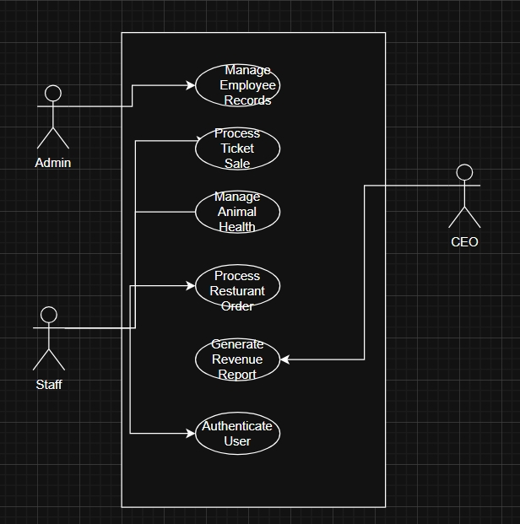

9.3 Sample Completed Questionnaire Summary (Consolidated Results)
AquaCore Aquarium Management Information System
To support the fact-finding process, questionnaires were distributed to selected staff members from different departments within AquaCore Aquarium, including Ticket Sales, Animal Care, Restaurant, Human Resources/Administration, and IT Support. A total of 7 respondents completed the questionnaire. Instead of attaching all individual complete questionnaires, the consolidated results are presented below to provide a clear summary of the key findings obtained from the responses.

Table 9.1: Consolidated Questionnaire Results

Question / Area Investigated | Consolidated Result
Current system method used in departments | 5 out of 7 respondents indicated that the current system is partially computerized, while 2 out of 7 indicated that it is fully manual.
Delays in accessing or updating information | 7 out of 7 respondents answered Yes, indicating that delays are consistently experienced.
Duplication of data / repeated data capturing | 6 out of 7 respondents answered Yes, showing that duplication of data is a common issue.
Frequency of errors in record-keeping | 5 out of 7 respondents indicated that errors occur sometimes, while 2 out of 7 indicated that errors occur often.
Poor record-keeping identified as a major problem | 7 out of 7 respondents selected Poor record-keeping as a major problem in the current system.
Lost or missing information | 5 out of 7 respondents selected Lost or missing information as a problem experienced in the current system.
Delayed reporting | 6 out of 7 respondents selected Delayed reporting as a major issue affecting operations.
Weak access control / security | 6 out of 7 respondents identified Weak access control / security as a major weakness in the current system.
Poor customer service due to delays | 5 out of 7 respondents indicated that delays negatively affect customer service delivery.
Difficulty tracking animal care tasks | 4 out of 7 respondents selected Difficulty tracking animal care tasks as a significant operational problem.
Restaurant stock inaccuracies | 3 out of 7 respondents reported Restaurant stock inaccuracies as a recurring issue.
Inaccurate revenue reporting | 6 out of 7 respondents identified Inaccurate revenue reporting as a major concern.
Difficulty generating accurate reports | 7 out of 7 respondents answered Yes, confirming that the current system makes it difficult to generate accurate reports.
Poor communication between departments | 6 out of 7 respondents answered Yes, indicating that communication problems exist between departments.
Need for role-based access control | 7 out of 7 respondents agreed that the new system should provide role-based access control according to department or user role.
Importance of ease of use | 7 out of 7 respondents indicated that it is Very Important for the new system to be easy to use.
Importance of real-time reporting | 6 out of 7 respondents rated real-time reporting as Very Important, while 1 out of 7 rated it as Important.
Need for staff training before implementation | 7 out of 7 respondents indicated that training will be required before the new system is implemented.

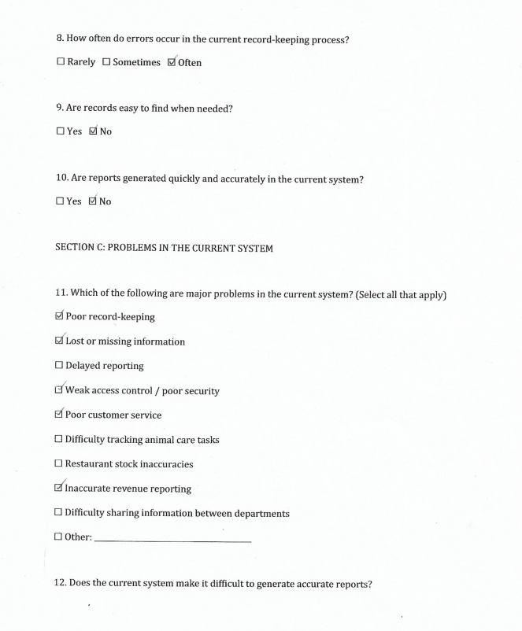
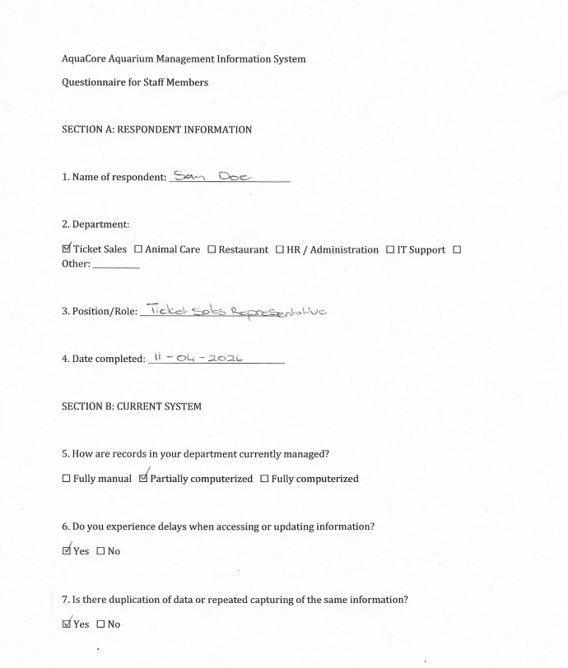
Example of filled in questionnaire

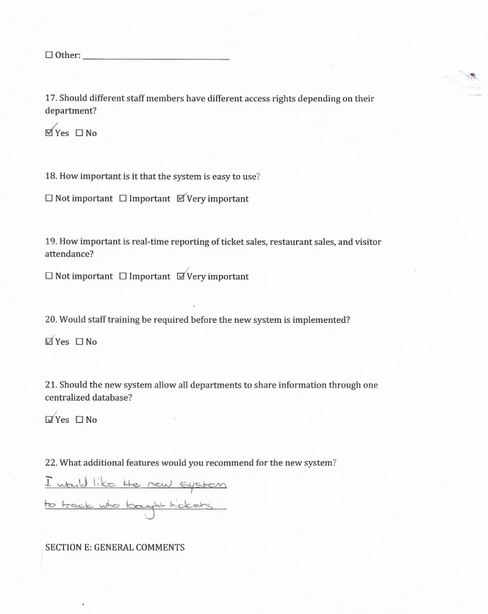
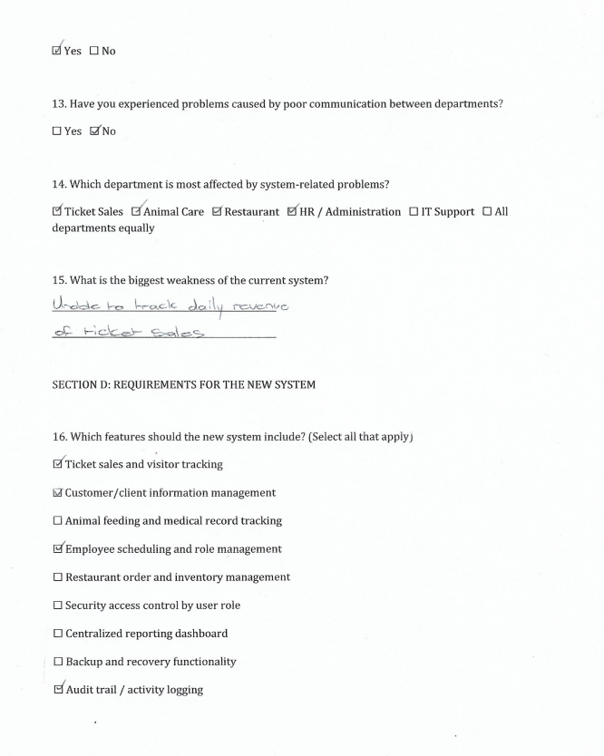
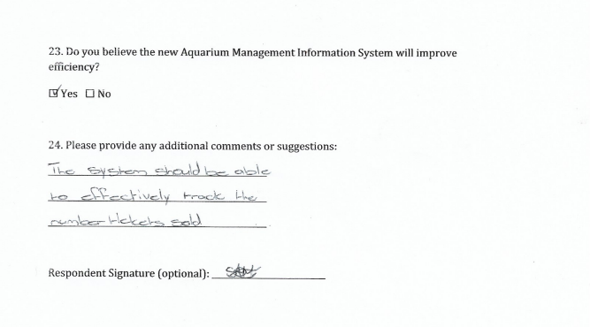

Summary, future and further planning
This document covered the requirements of AquaCore Aquarium and thus concluding Scope analysis, Problem analysis and Requirement analysis phases. After the requirements document has been accepted, the team will proceed to the Logical Design phase in which it will be completed on the 8th of May 2026.